**Things to Learn.**

* **Agile Methodology**

# Overview of Agile Methodology

Agile methodologies are approaches to product development that are aligned with the values ​​and principles described in the [Agile Manifesto](https://agilemanifesto.org/) for software development. Agile methodologies aim to deliver the right product, with incremental and frequent delivery of small chunks of functionality, through small cross-functional self-organizing teams, enabling frequent customer feedback and course correction as needed.

In doing so, Agile aims to right the challenges faced by the traditional “waterfall” approaches of delivering large products over long periods, during which customer requirements frequently changed, resulting in the wrong products being delivered.

Agile methods also include technical practices – most of which fall under the umbrella term DevOps – that enable Test Automation, Continuous Integration/ Continuous Delivery/ Deployment (CI/ CD), and overall, an ever-shrinking delivery cycle for software and other products and services.

* **Scrum**

Scrum is an agile development methodology used in the development of Software based on iterative and incremental processes. Scrum is an adaptable, fast, flexible, and effective agile framework that is designed to deliver value to the customer throughout the development of the project. The primary objective of Scrum is to satisfy the customer’s needs through an environment of transparency in communication, collective responsibility, and continuous progress. The development starts from a general idea of ​​what needs to be built, elaborating on a list of characteristics ordered by priority (product backlog) that the owner of the product wants to obtain.

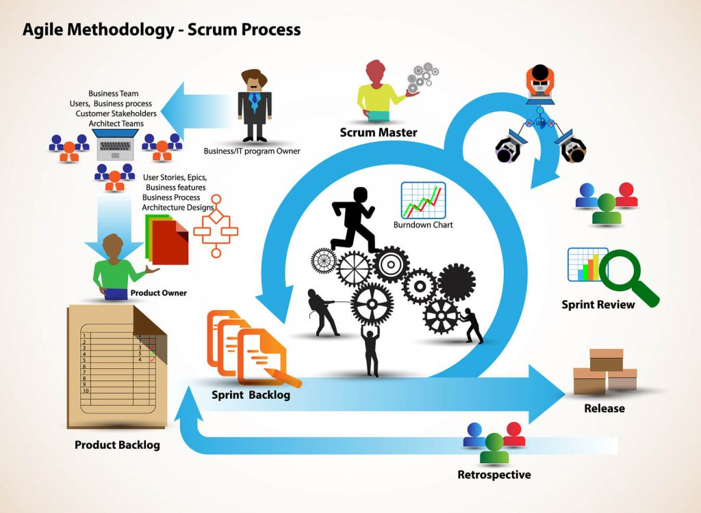

In Scrum, the team focuses on building quality software. The owner of a Scrum project focuses on defining what are the characteristics that the product must have to build (what to build, what not, and in what order) and overcoming any obstacle that could hinder the task of the development team.

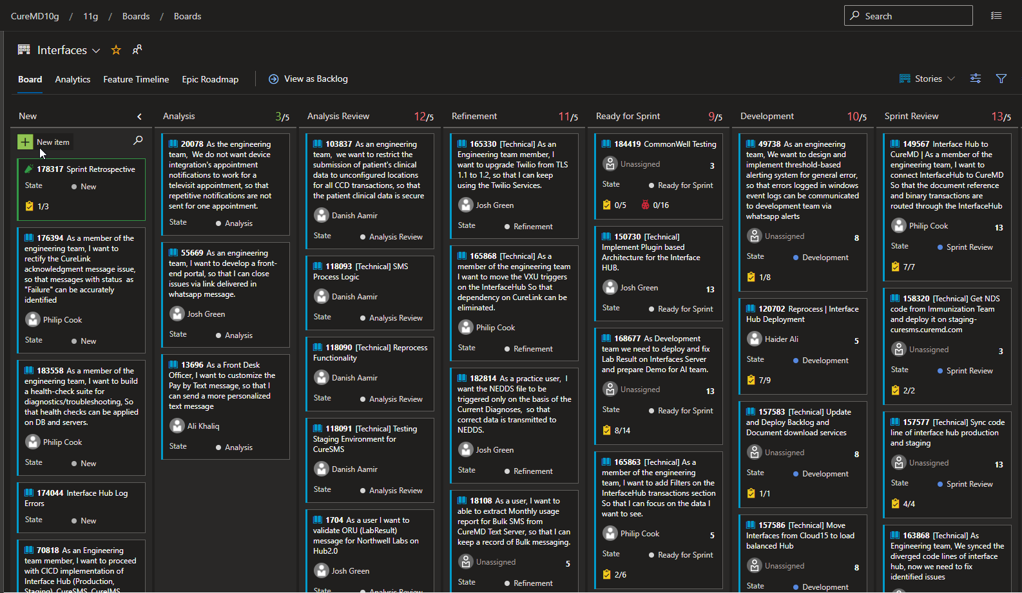

## <https://www.youtube.com/watch?v=DbCvs-60ytM>

* **DevOps**

DevOps is the combination of cultural philosophies, practices, and tools that increases an organization’s ability to deliver applications and services at high velocity: evolving and improving products at a faster pace than organizations using traditional software development and infrastructure management processes. This speed enables organizations to better serve their customers and compete more effectively in the market.

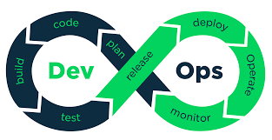

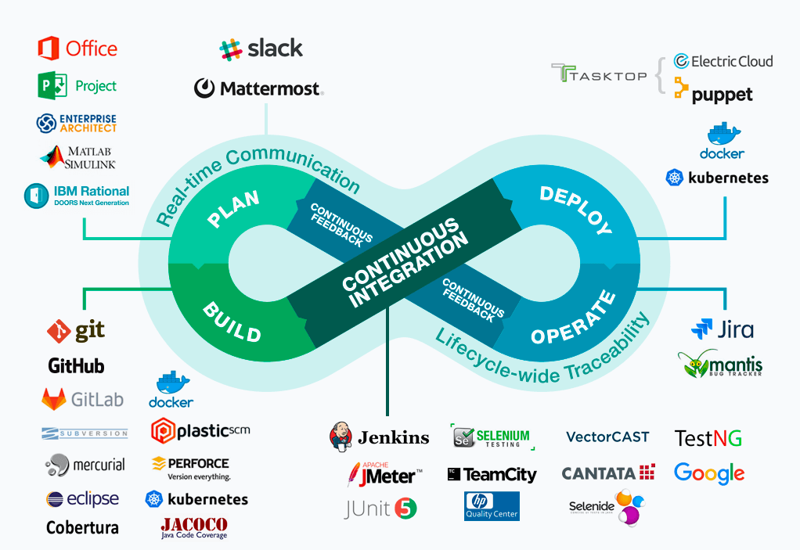

How DevOps Works

Under a DevOps model, development and operations teams are no longer “siloed.” Sometimes, these two teams are merged into a single team where the engineers work across the entire application lifecycle, from development and test to deployment to operations, and develop a range of skills not limited to a single function.

In some DevOps models, quality assurance and security teams may also become more tightly integrated with development and operations and throughout the application lifecycle. When security is the focus of everyone on a DevOps team, this is sometimes referred to as DevSecOps.

These teams use practices to automate processes that historically have been manual and slow. They use a technology stack and tooling which help them operate and evolve applications quickly and reliably. These tools also help engineers independently accomplish tasks (for example, deploying code or provisioning infrastructure) that normally would have required help from other teams, and this further increases a team’s velocity.

* <https://app.pluralsight.com/library/courses/devops-big-picture/>
* <https://app.pluralsight.com/library/courses/continuous-integration-delivery-big-picture/>
* **DevOps Concepts we are using**

1. **Azure DevOps**

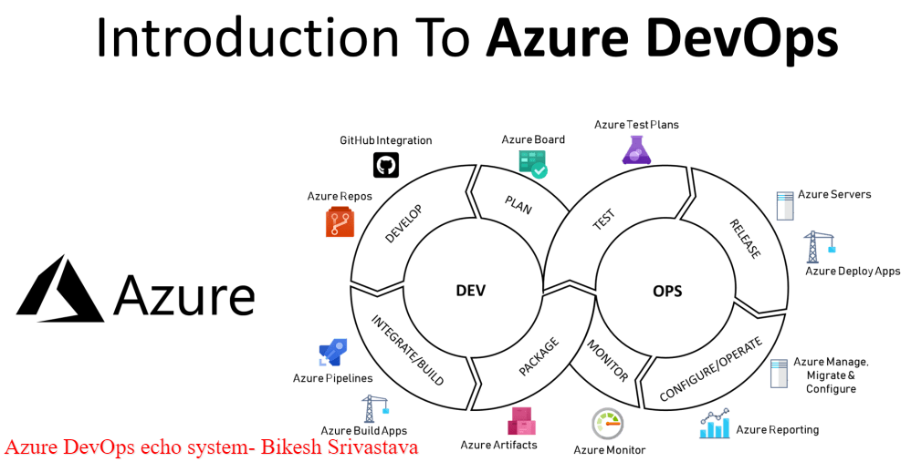

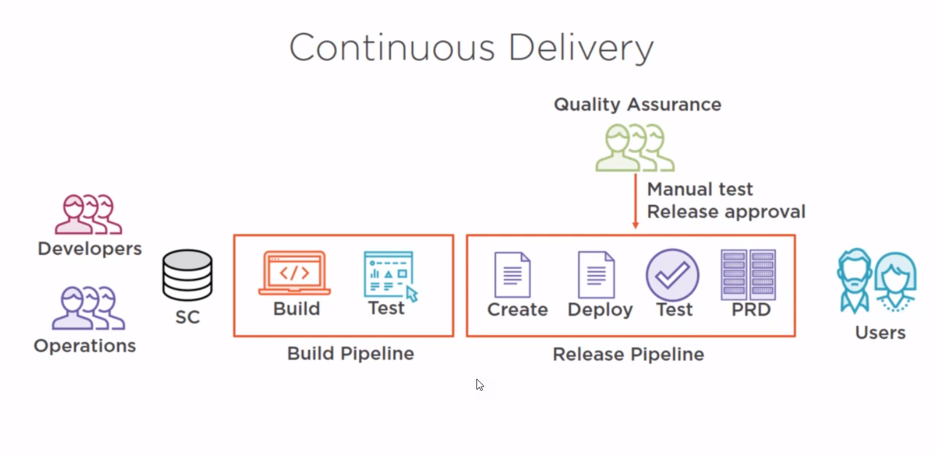

* <https://youtu.be/JhqpF-5E10I>
* <https://youtu.be/NuYDAs3kNV8>
* <https://app.pluralsight.com/library/courses/azure-devops-continuous-delivery-source-control>
* <https://app.pluralsight.com/library/courses/continuous-delivery-azure-devops-big-picture>
* <https://app.pluralsight.com/library/courses/azure-devops-continuous-delivery-managing-builds>
* <https://app.pluralsight.com/library/courses/azure-devops-continuous-delivery-release-pipelines>

1. **mRemoteNG**

mRemoteNG is a fork of mRemote: an open source, tabbed, multi-protocol, remote connections manager for Windows. mRemoteNG adds bug fixes and new features to mRemote and allows you to view all of your remote connections in a simple yet powerful tabbed interface. We have remote connections to the clouds, counties, and local servers.

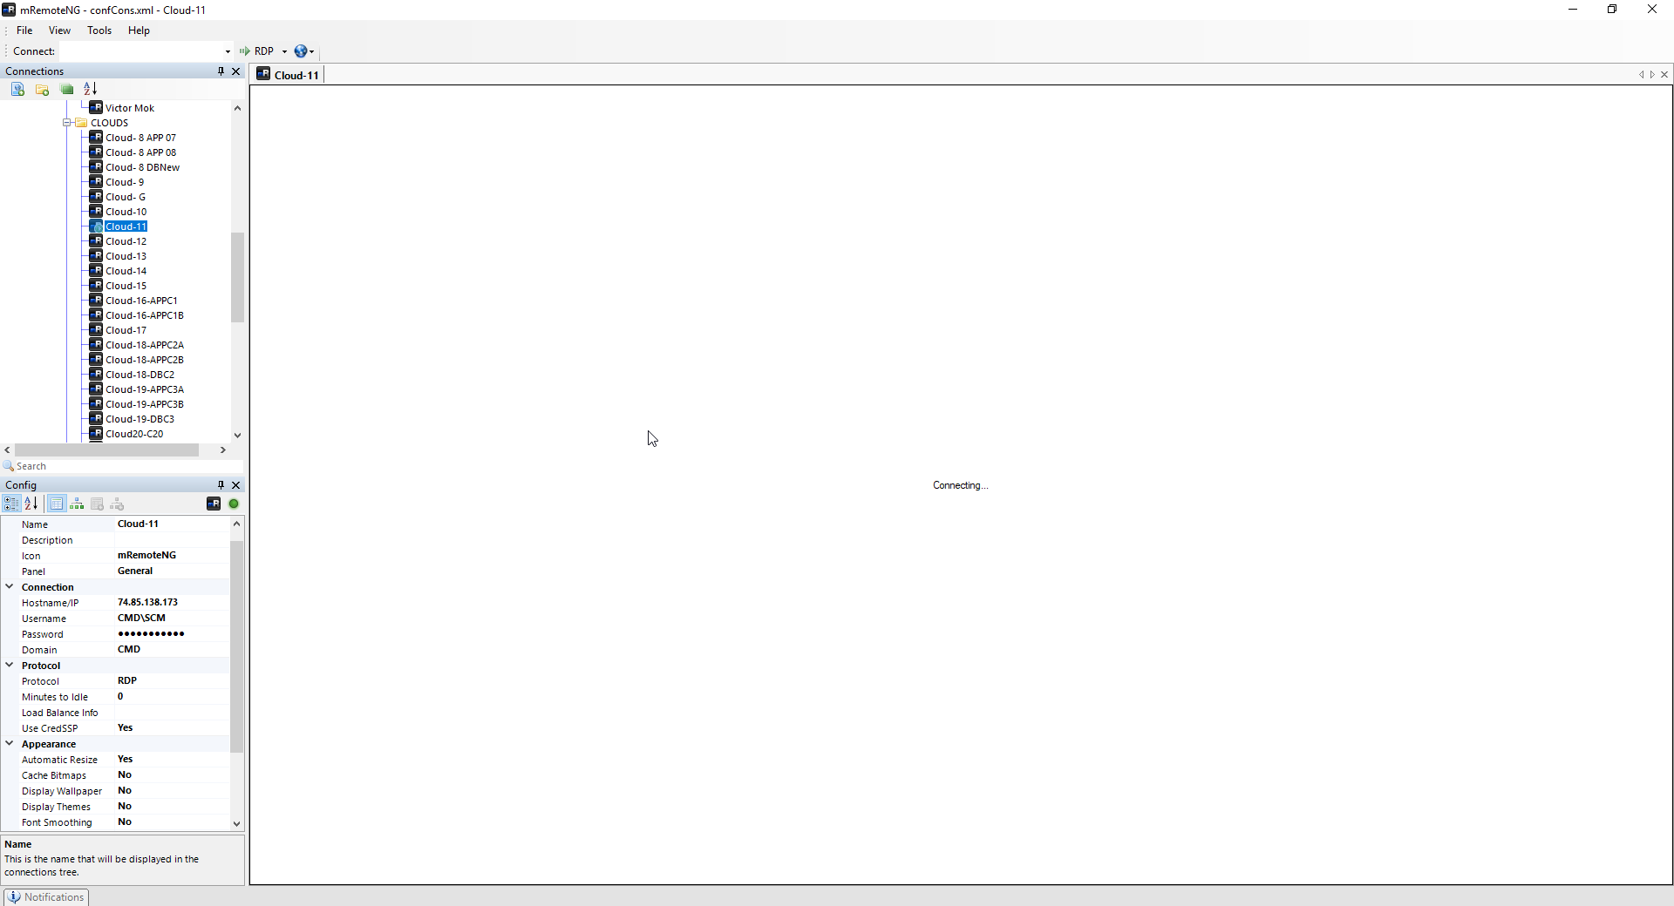

1. **SFTP**

What is SFTP?

SFTP (Secure File Transfer Protocol) is a file transfer protocol that leverages a set of utilities that provide secure access to a remote computer to deliver secure communications. It is considered by many to be the optimal method for secure file transfer. It leverages SSH (Secure Socket Shell or Secure Shell) and is frequently also referred to as ‘Secure Shell File Transfer Protocol‘.

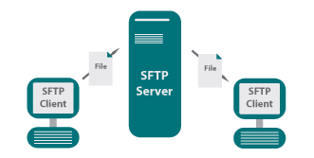

1. **Internet Information Services IIS Manager**

Most commonly, IIS is used to host ASP.NET web applications and static websites. It can also be used as an FTP server, host WCF services, and be extended to host web applications built on other platforms such as PHP. There are built-in authentication options such as Basic, ASP.NET, and Windows auth.

What Is a Web Server?

The internet is good. And the internet cannot exist without web servers. But what exactly is a web server? Let’s define that in the abstract so we can have some context for how IIS fills this role.

A web server is a process for hosting web applications. The web server allows an application to process messages that arrive through specific TCP ports (by default). For example, the default port for HTTP traffic is 80, and the one for HTTPS is 443.

When you visit a website in your browser, you don’t typically specify the port number unless the web server is configured to receive traffic on ports other than the default. Visiting http://www.example.com will send your request to port 80 implicitly. You could specify the port number if you’d like http://www.example.com:80, and https://www.example.com:443 for TLS (Transport Layer Security).

Assuming the default configuration and TLS are configured for your web application, the web server will receive all inbound traffic to ports 80 and 443. What the web server does with the traffic from there depends. There are countless options for how the web server can process those requests.

How does IIS handle web requests?

The two main process models for web servers are to either handle all requests on a single thread or to spawn a new thread for each request. Although the single-thread model (Node.js, for example) has some worker threads available, it typically only uses them for certain kinds of work, such as file system access. The thread-per-request model that IIS (and its lightweight cousin IIS Express) uses will grab a thread from a thread pool for each request.

Web servers typically handle requests using a request-response pattern. The client sends a request and receives a response if all goes well. The HTTP protocol is the ubiquitous choice when communicating between a client and a web server over the internet.

Features

IIS is rich in features. Most commonly, IIS is used to host ASP.NET web applications and static websites. It can also be used as an FTP server, host WCF services, and be extended to host web applications built on other platforms such as PHP.

There are built-in authentication options such as Basic, ASP.NET, and Windows auth. The latter is useful if you have a Windows Active Directory environment—users can be automatically signed into web applications using their domain account. Other built-in security features include TLS certificate management and binding for enabling HTTPS and SFTP on your sites, request filtering for whitelisting or blacklisting traffic, authorization rules, request logging, and a rich set of FTP-specific security options.

One key feature of IIS is the application pool. We’ll have to take a closer look at the application pool, as it’s a critical component of the IIS process model.

An invaluable feature is a remote management. IIS can also be managed via the CLI or using PowerShell. You can script everything, which is great if you like the power that comes with being able to do so.

By now, you should have a good impression of the reconfigurability and versatility of IIS. You should also be aware that it can be extended to serve (pun intended) many purposes besides hosting ASP.NET apps. Through extension, IIS becomes a highly versatile and stable web server for the Windows platform. Let’s take a look at how to install IIS on Windows 10. (The same process applies to Windows 7 and 8.)

**The GUI**

Before we get into details, I want to give you a quick intro to the IIS Manager. I’ve highlighted the areas of interest because this thing is such a mess. It takes some getting used to, but there are a few things I can offer to help with, as it concerns getting around in here.

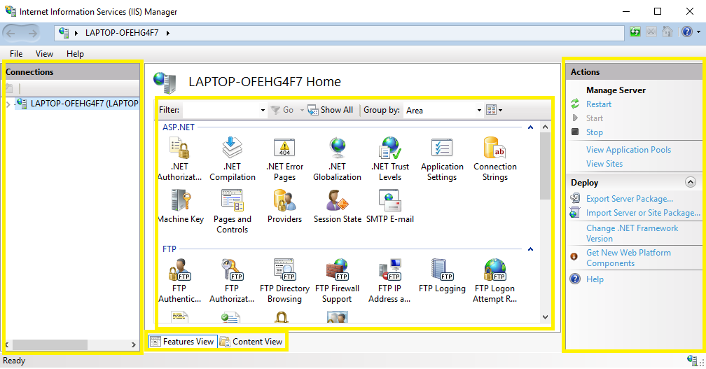

* **Power Shell Programming**

Windows PowerShell is an object-oriented automation engine and scripting language. It is designed mainly for IT professionals and system administrators to control & automate the administration of Windows OS and other applications. It provides compelling new concepts to extend the knowledge you have gained and scripts you have created within the Windows Command Prompt and Windows Script Host environments.

* <https://app.pluralsight.com/paths/skills/windows-powershell-essentials>
* <https://app.pluralsight.com/library/courses/powershell-getting-started/table-of-contents>
* **Batch File Programming**

Batch programming is a programming paradigm that can execute certain commands automatically at the level of an operating system such as DOS or Windows 7 / XP. A batch file is a stack of such commands. If it is retrieved with the command line, the system will execute each task listed in succession. Therefore, the term batch processing is quite common. Batch files are often used to control and configure operating systems, but can also be used for other operations such as server installations. The most famous is probably the Autoexec.bat file that starts the DOS operating system.

* + <https://www.tutorialspoint.com/batch_script/index.htmc>